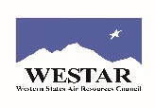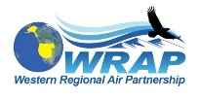

Agenda for WESTAR-WRAP FSWG call on June 28, 2021
11 am – 12:30 pm Pacific, Noon -1:30 pm Mountain

Microsoft Teams meeting
Join on your computer or mobile app
Click here to join the meeting
Or call in (audio only)
+1 323-676-6261, 770204663#
Phone Conference ID: 770 204 663#

- Roll call (5-10 min) – All

- Idaho Wildfire Smoke Coordination, Communication, and Stakeholder Engagement – Mark Boyle, Sally Hunter (10-15 mins + time for questions)

- Conceptual Model for Fire Data project – Tom Moore
  - Update on workshop plans

- Review draft update to fire and smoke EE resource document – Bob

- Update on the workgroup’s new teams (10-15 mins.) – Co-Chairs

  - Efforts moving forward with forming the 4 new teams

    - Refining the Smoke Management Plan (SMP) mapping tool – Rhonda & Paul

    - Exceptional Events Support Team – Bob
      - Revised EE resource document
      - First meeting scheduled for July 8, 9AM Pacific

    - Prescribed Fire and Wildfire Nexus – Paul & Bob
      - Letting this one simmer until after Regional Haze SIPs are turned in.

    - Education, Outreach and Training – Rhonda

- Schedule next FSWG call – propose Monday July 26: 11 am – 12:30 pm Pacific, Noon -1:30 pm Mountain

